Lab Task for Analysis of Algorithm
Name:Umar Ahad Uddin Ahmed Usmani
SAP :60199

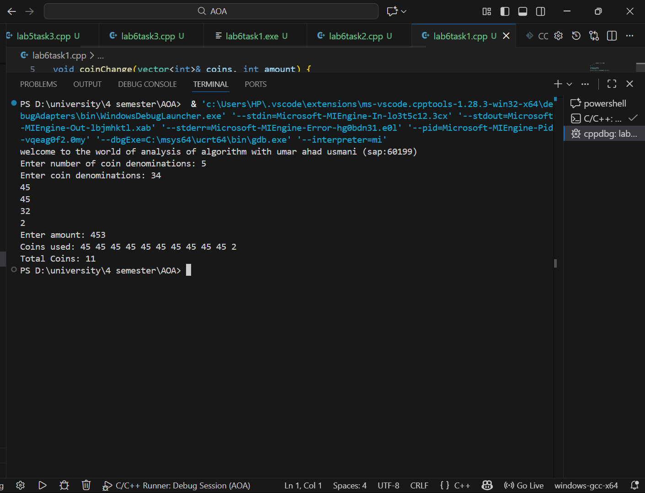

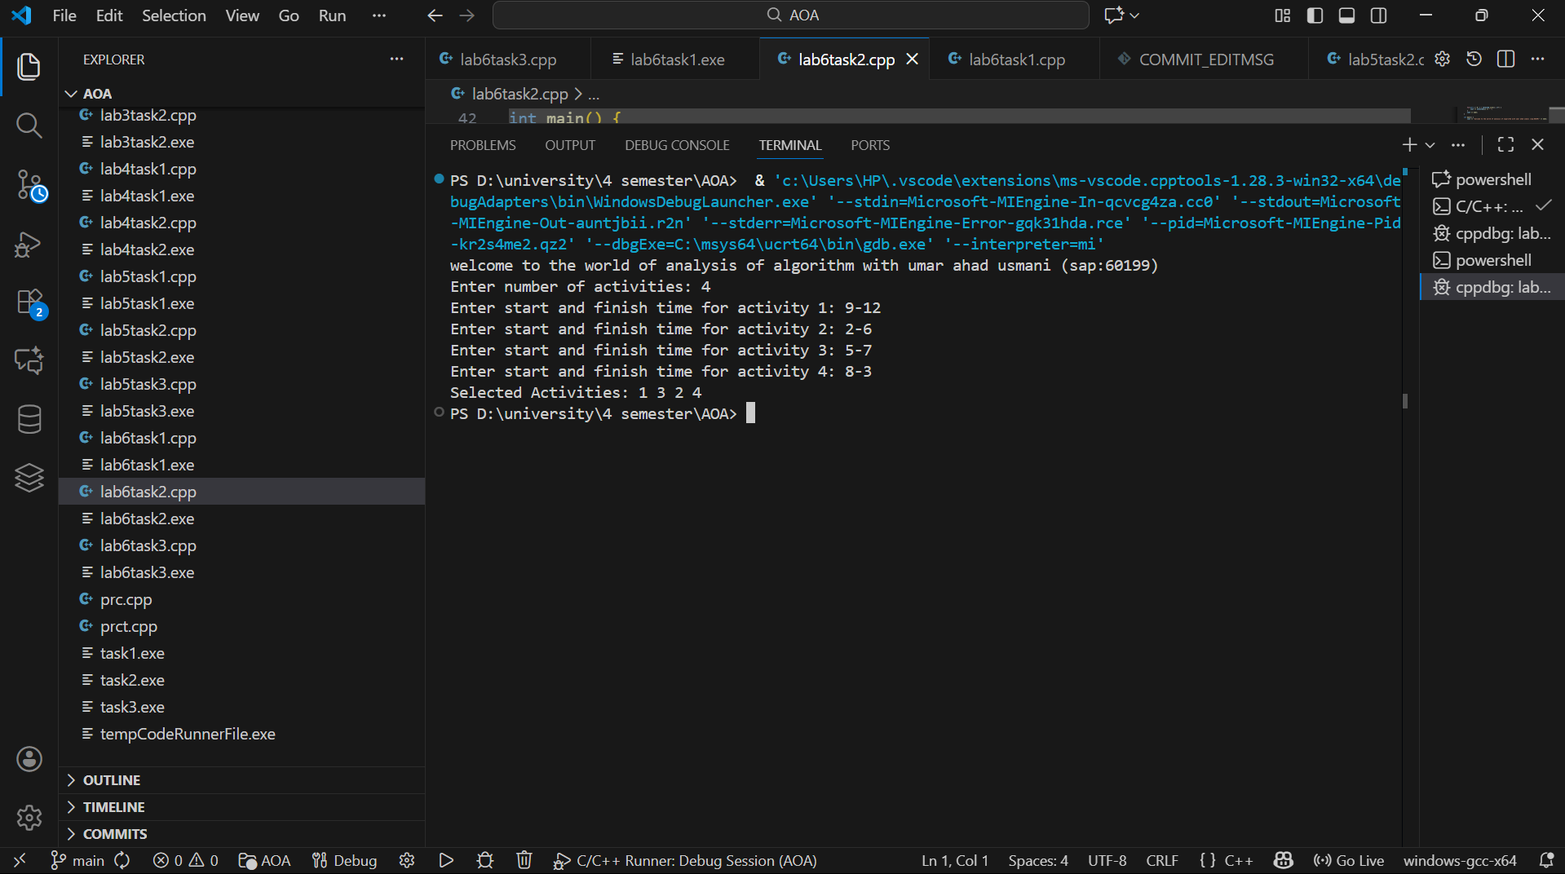

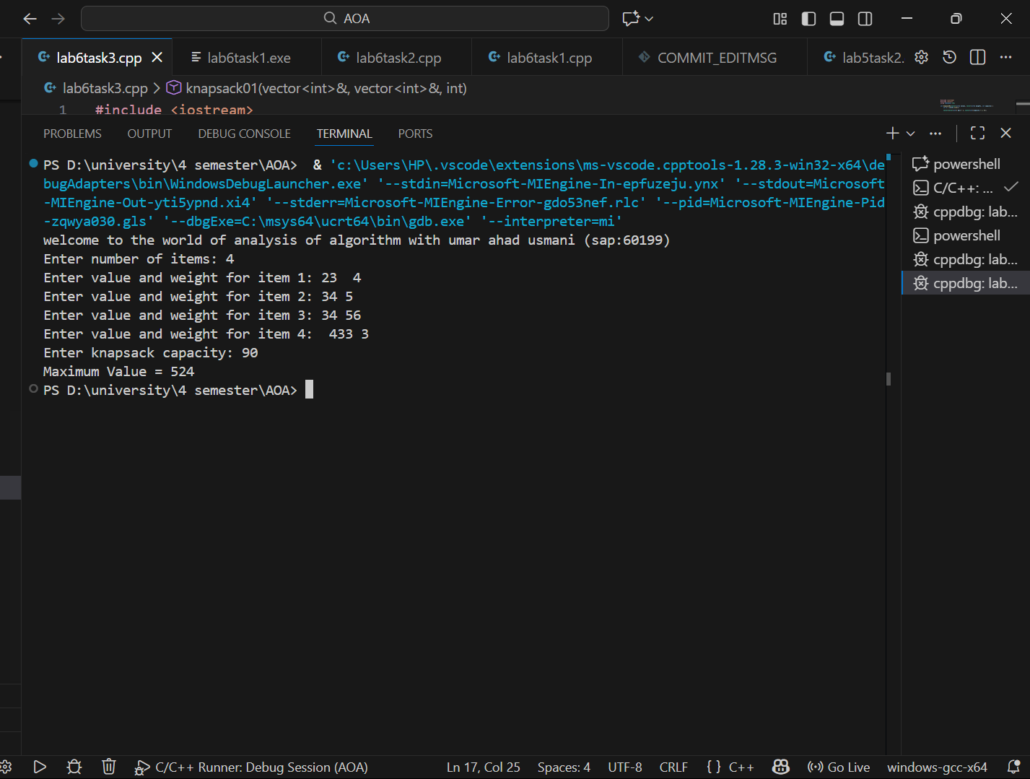

Github repo link : https://github.com/umarahad2005/AOA

